The American Society of Military Museum

A California Non-Profit Educational Organization

EST. 1962

Partnership in Education Program

Committed to the education and preservation of military vehicles and their history, the American Society of Military History is a California Non-Profit Educational Organization that seeks to pass on the knowledge of past generations. Located in the Whittier Narrows Recreation Area in South El Monte, CA, the museum affectionately known as ‘Tankland’ boasts an impressive and historically significant collection of over 170 different pieces of equipment on display.

Our museum features vehicles and equipment from World War One, World War Two, the Korean War, Vietnam War, Cold War, and Operation Desert Storm. This vast collection illustrates the advancement of military technology, showing the transformation from horse drawn artillery to self-propelled cannons and tanks.

We are inviting History teachers from local schools and universities to visit the American Military Museum as part of our Partnership in Education Program. Our Museum is available for student tours, and has a gallery online for students to research from. To supplement our educational program, we provide students with study guides they could use for additional learning. These study guides serve as a great extra credit opportunity for you to implement into your course program, and will hopefully provide students with additional knowledge. Our Museum can also serve as a site for Community Service Volunteer requirements.

Goals
- Reach out to our local community
- Introduce historical vehicles and equipment to the next generation
- Educate today’s students about America’s Military History
- Increase awareness of our Museum
- Increase museum membership
- Increase musuem Volunteer Base

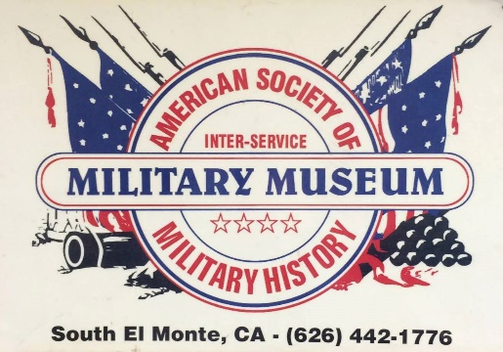
The American Military Museum is a great local resource and we feel confident your students will enjoy seeing these historical artifacts up close and in person. Thank you for your support of our museum, and we hope to see you and your students soon!

American Military Museum & Restoration center, Whittier Narrows Recreation Area
1918 Rosemead Blvd. South El Monte, CA 91733
Tel: (626) 442-1776
Email: tankland@aol.com / www.tankland.com

